DEMO APP — TEST EXECUTION RESULTS
Setup verification, functional testing & evidence log
Environment: Windows 11 | Podman 5.x | Tested by: skquo

Summary
Area Tested | Result
Environment setup (podman-compose, Maven/Java 21, port check) | PASS
Podman machine + all containers healthy | PASS
Claims Service & BFF Service health endpoints | PASS
Admin login & dashboard | PASS
Claimant login & claim submission | PASS
Role-based access control (admin vs claimant views) | PASS
Admin claim status update (Approve/Reject) | PASS
Cross-role sync (claimant sees admin's status change) | PASS
Kafka event streaming — claim-submitted events | PASS
Kafka event streaming — claim-status-changed events | PASS
CDC topic (cdc.demo-app.public.claims) | NOTE — 0 messages, not wired up

Part 1 — Environment Setup Verification
STEP 1 · Verify podman-compose is installed
pip install podman-compose
RESULT: Already installed — podman-compose v1.6.0 confirmed via pip output.
STEP 2 · Verify Maven resolves to Java 21
mvn --version
RESULT: Java version: 21.0.12, Eclipse Adoptium — correct, no JAVA_HOME override needed.
STEP 3 · Check port 8080 availability
netstat -ano | findstr ":8080"
tasklist /FI "PID eq 17080"
RESULT: Port 8080 in use by wslrelay.exe (WSL2), later confirmed to be the project's own demo-claims-service container — not a conflict.
STEP 4 · Verify Podman machine status
podman machine list
RESULT: podman-machine-default already running (4 weeks old, 6 CPUs, 2GiB RAM, 100G disk).
STEP 5 · Verify all containers are healthy
podman ps -a
RESULT: All 9 containers (postgres, zookeeper, redis, keycloak, kafka, kafka-ui, claims-service, bff-service, ui) Up and healthy — 4 days uptime.
STEP 6 · Health check endpoints
curl.exe http://localhost:8080/actuator/health # Claims Service
curl.exe http://localhost:8090/actuator/health # BFF Service
RESULT: Claims Service returned HTTP 200. BFF Service returned {"groups":["liveness","readiness"],"status":"UP"}.

Part 2 — Functional Testing (UI, Roles, Kafka)
STEP 7 · Admin Dashboard
Logged in as admin@demo.com. Dashboard shows Total Users, Total Claims, and Claims by Status breakdown, plus a Redis cache performance demo.
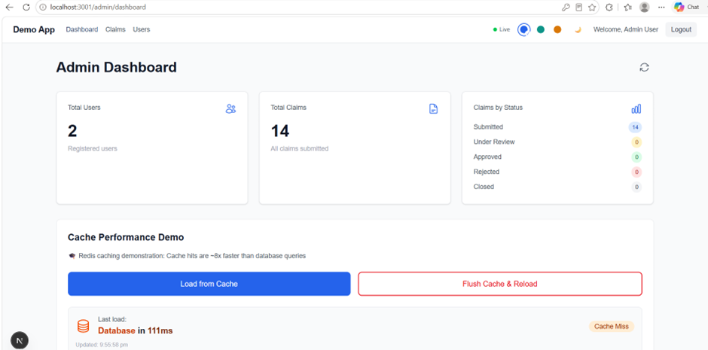
RESULT: Admin dashboard loads correctly with live aggregate stats.
STEP 8 · Admin — User Management
Admin can view all registered users and their roles (Claimant / Admin).
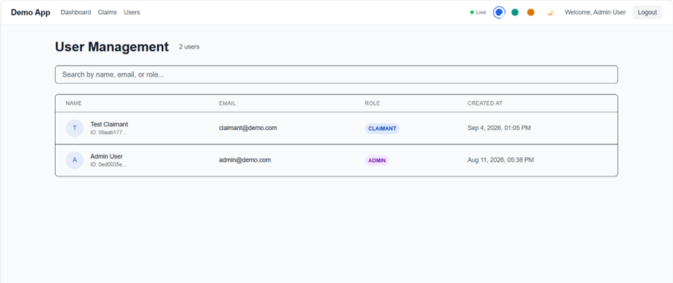
RESULT: User Management page correctly lists both test users with role tags.
STEP 9 · Claimant — My Claims
Logged in as claimant@demo.com. Claimant sees only their own submitted claims, with a Submit New Claim action.
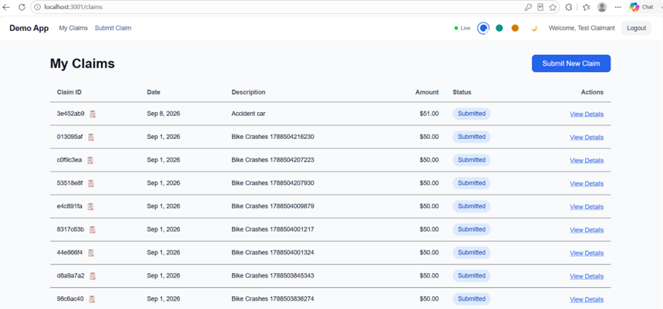
RESULT: Role difference confirmed: claimant has a submission-focused view vs. admin's aggregate view.
STEP 10 · Admin — Claims Management
Admin's Claims tab lists every claim across all users with a per-row Update Status dropdown (Under Review / Rejected / Approved).
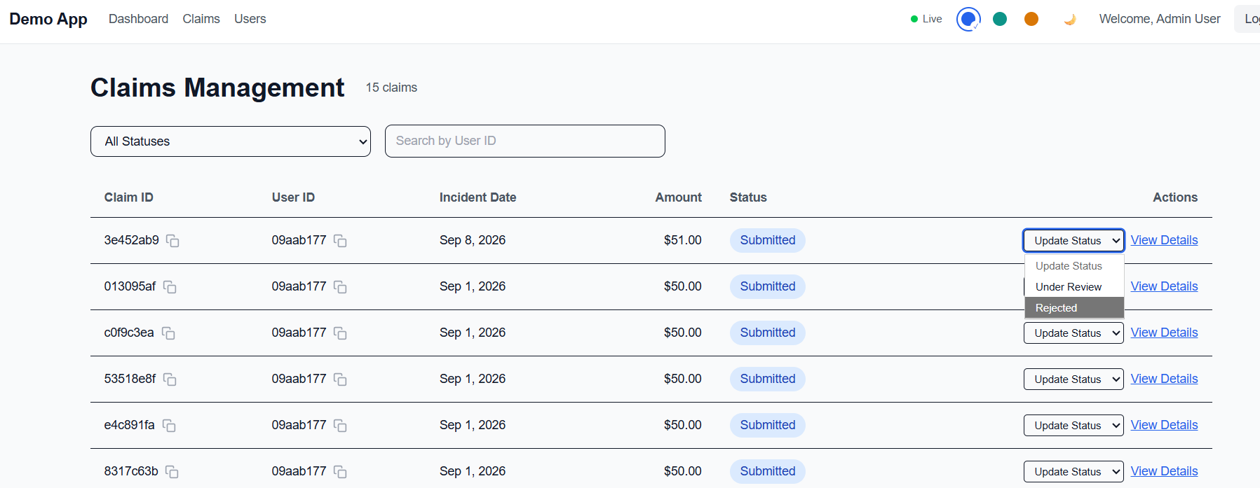
RESULT: Full claims list visible to admin with working status-update control.
STEP 11 · Admin — status updated (Approved / Rejected)
Updated claim 3e452ab9 to Approved, and 013095af / c0f9c3ea to Rejected.
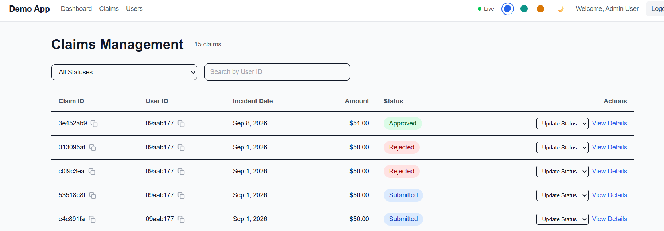
RESULT: Status changes persisted and displayed correctly in Claims Management.
STEP 12 · Claimant — sees admin's status change
Logged back in as claimant. Same claims now show Approved / Rejected, matching admin's changes exactly.
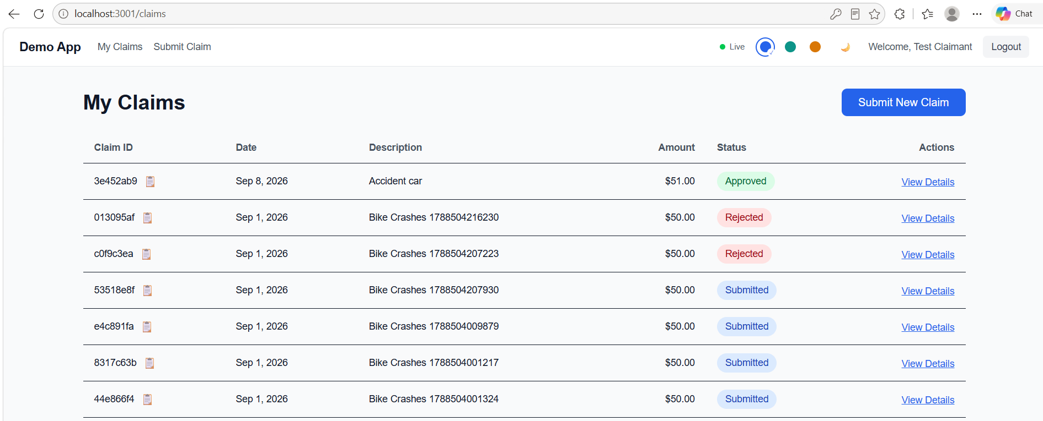
RESULT: Cross-role sync confirmed — no caching lag, statuses match immediately.
STEP 13 · Kafka UI — cluster dashboard
Checked Kafka UI (localhost:9093) to confirm the event-streaming layer is active.
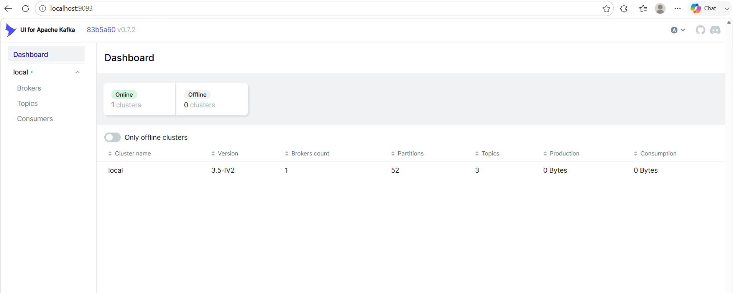
RESULT: Cluster online, 1 broker, 3 topics, 52 partitions.
STEP 14 · Kafka UI — topics
Checked message counts per topic.
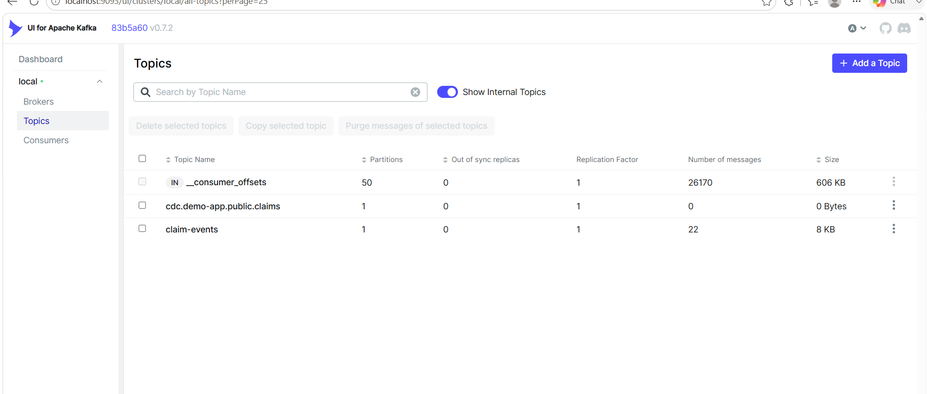
RESULT: claim-events: 22 messages (8 KB). cdc.demo-app.public.claims: 0 messages (not wired up — flagged as a note, not a defect).
STEP 15 · Kafka UI — claim-submitted events
Inspected claim-events messages, oldest first.
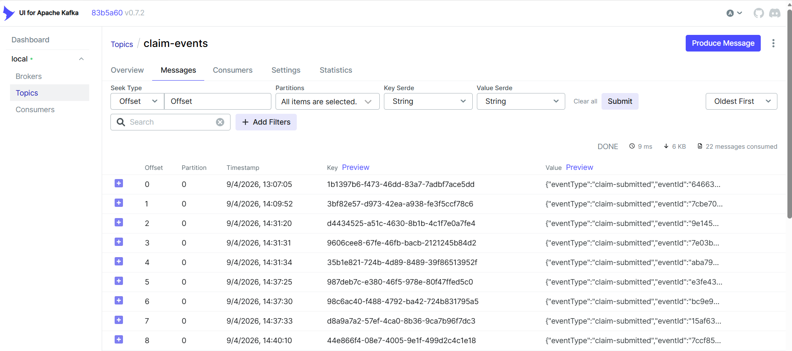
RESULT: Each claim submission produced a claim-submitted event with a unique eventId.
STEP 16 · Kafka UI — claim-status-changed events
Switched to newest-first and inspected the latest events, matching the status changes made in Step 11.
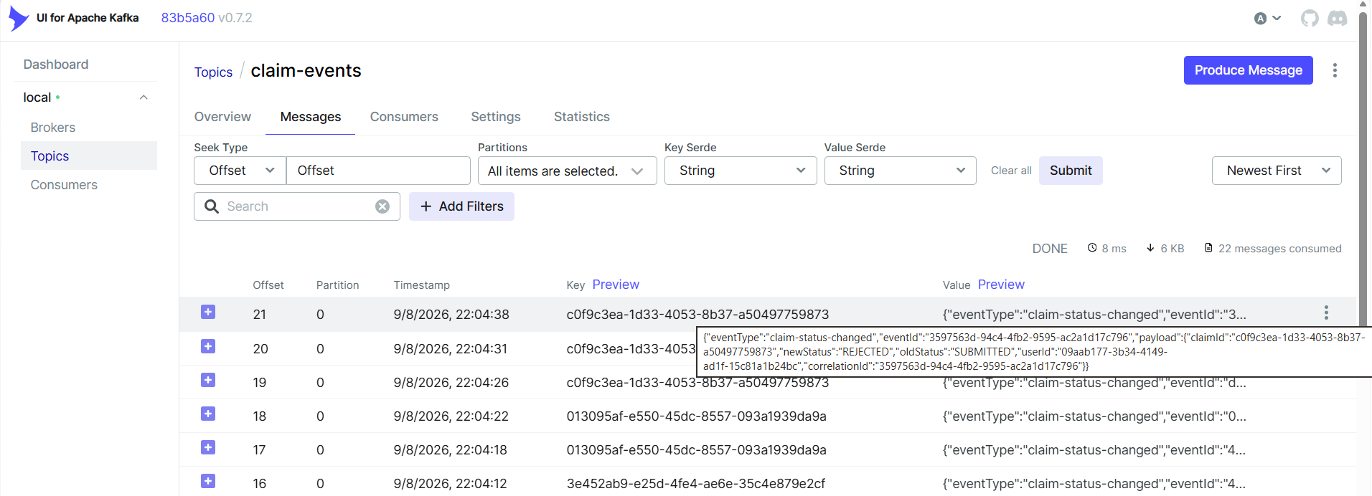
RESULT: Confirmed claim-status-changed event for claim c0f9c3ea with oldStatus=SUBMITTED, newStatus=REJECTED, correct userId and correlationId. Full UI → API → DB → Kafka pipeline verified.

Open Items / Notes
Item | Note
cdc.demo-app.public.claims topic empty | 0 messages — likely CDC/Debezium not connected in this environment. Confirm if in scope before reporting as a defect.
Dashboard claim count briefly showed 14 vs 15 in Claims Management | Resolved on refresh — appears to be timing, not a stale-cache bug. Monitor if it recurs.

